**CRX All in one engine management**

**Goal:**

To replace the fuse/relay box of a 1988 Honda CRX as well as the Integrated Control Unit (ICU) into a compact, race-customizable, energy efficient, modular unit. This standalone unit will handle all cabin functions of the CRX including but not limited to exterior light control, door control, interior lighting control, along with various custom input / output / memory management. There will be future documents that explains the development of other systems.

* This document might include a port for audio equipment; overall, audio will not be the scope of this document.
* This document might include various ports for lighting with various notes; overall, the lighting design will not be the scope of this document.

Focus of this document includes:

1. Power distribution redesign ( compact, power [wattage] reduction )
2. Mechanical to digital redesign of the user feedback ( gauges / displays )
3. If electricity runs through it, this document will describe the adaption to the overall impact of the project

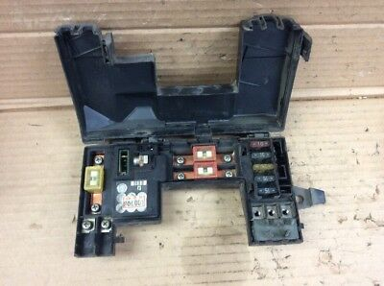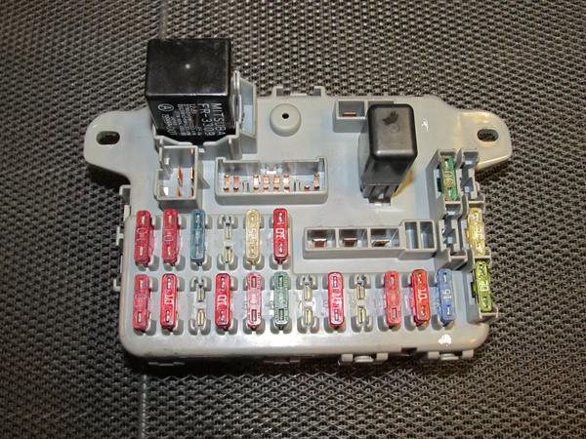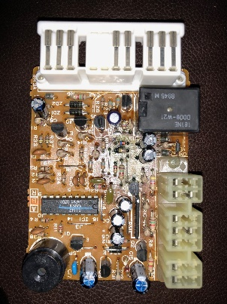

Left: Main Power Distribution (O.E.)  
Middle: General purpose fuses (sub power distribution O.E.)  
Right: User purpose functions (Logic distribution O.E.) Honda Integrated control unit  
  
These three parts will try to be combined into one standalone unit also encompassing but not limited to:

* GPS tracking
* Active alarm
* Active datalogging
* Added input output for race purpose
* Split high current applications for modules such as solenoids and other types of inductive load and resistive loads
* Complete modularization

**Power Redistribution:**

Frist we must acknowledge minimum user input.

1. **Starting I/O**
2. RFID circuit
3. Preignition verification ( Keys / Code )
4. Honda O.E. main relay reimagined for higher fuel priming. Replacement of main relay with 555 timer and proper interrupt ISR will support proper prime. ECU wire for Main relays must be redirected into MCU.
5. Preemptive start circuit ( “Gotta go” [ dark ] mode / Track mode ) secure interrupt driven / tune drive
6. False start circuit
7. **Accessory I/O**
8. Radio / Amplifier toggle
9. Window control
10. Interior / exterior lighting and control active mode.
11. **Required I/O**
12. False start integration
13. MCU ignition output control redirection
14. Engine related sensor electrical lock release (preignition verification driven)
15. **Lighting I/O**
16. Exterior
17. Low / High beam front
18. Blinder, top
19. Indicators two front systems, two rear. Hazzard ISR synchronization.
20. Brake, rear. Dark mode integration via secure interrupt
21. Tron system
22. Interior
23. Interior lighting active / passive / alert mode.
24. **Race purpose I/O**
25. Exhaust cutout control
26. Brake boost input
27. Data logging control
28. HUD race toggle
29. **Constant power I/O**
30. MCU power circuit
31. Door control
32. Security
33. GPIO

Stock power distribution table

|  |  |  |  |  |  |  |
| --- | --- | --- | --- | --- | --- | --- |
| Module | Min Power | Max P | OE Power | Resistance | Subunits | Power Diff |
| Starting | 0.8kw | 1.4kw | Check | - | 1 | 0% |
| Start Control | 160mW | 80mW | 50A | $$75 Ω-150 Ω$$ | 1 | +% |
| Ignition A | - | - | 50A | - | 21 | -% |
| Ignition B | - | - | 30A | - | 1 | -100% |
| Lighting | - | - | 40A | - | 10 | -% |
| Accessory | - | - | 15A | - | 5 | +% |
| Mains | - | - | 60A + 10A | - | 2 | - |

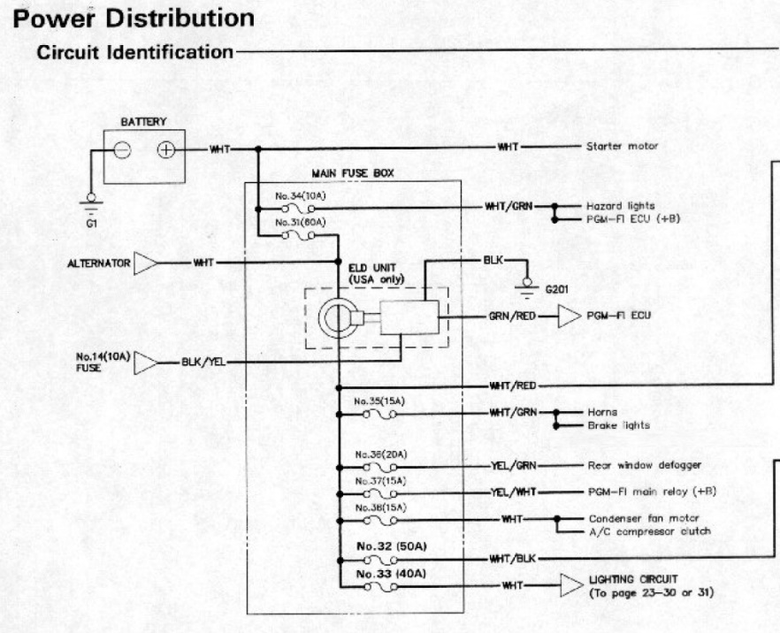

Figure i OE

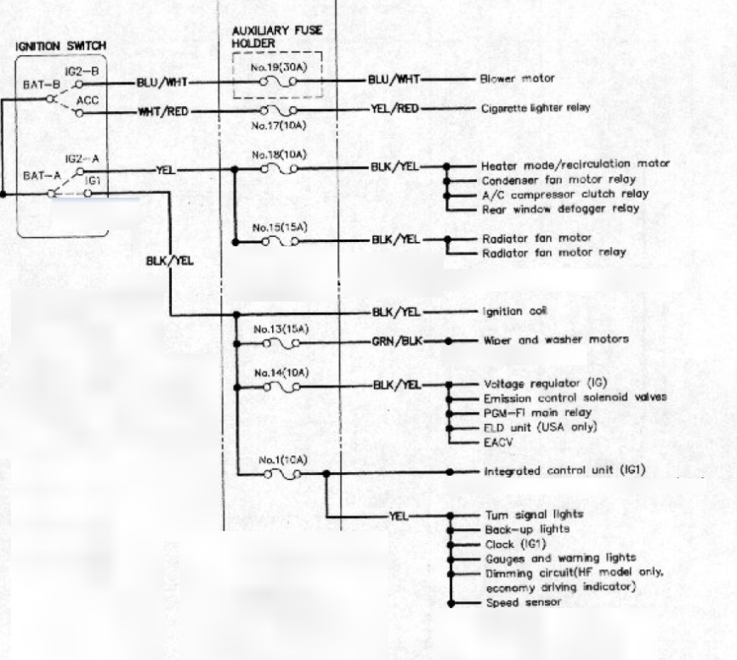

Figure ii OE IGNITION

Project power distribution table

|  |  |  |  |  |  |  |
| --- | --- | --- | --- | --- | --- | --- |
| Module | Min Power | Max P | OE Power | Resistance | Subunits | Power Diff |
| Starting | 0.8kw | 1.4kw | Check | - | 1 | 0% |
| Start Control |  |  |  |  |  | +% |
| Ignition A |  |  |  |  |  | -% |
| Lighting |  |  |  |  |  | -% |
| Accessory |  |  |  |  |  | +% |
| Mains |  |  |  |  |  | - |

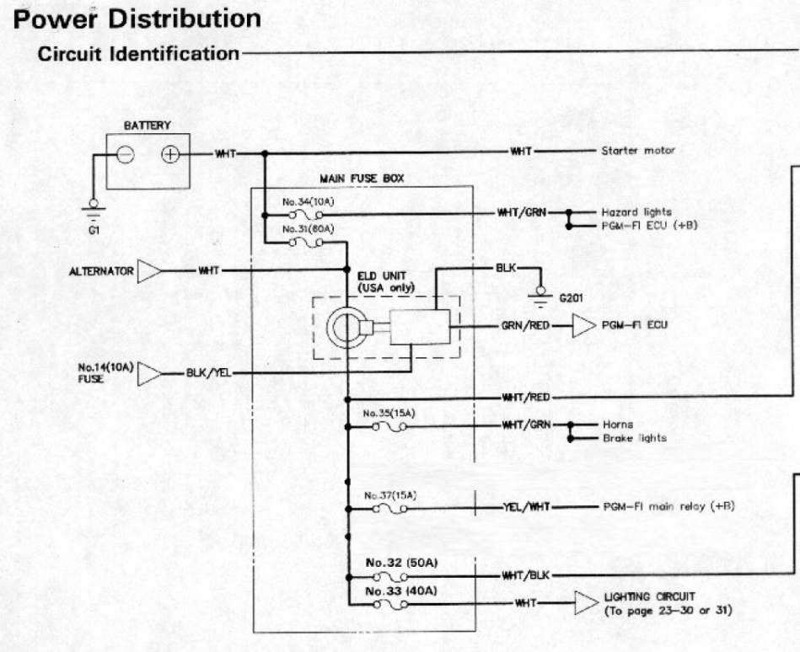

Figure Anticipated Custom

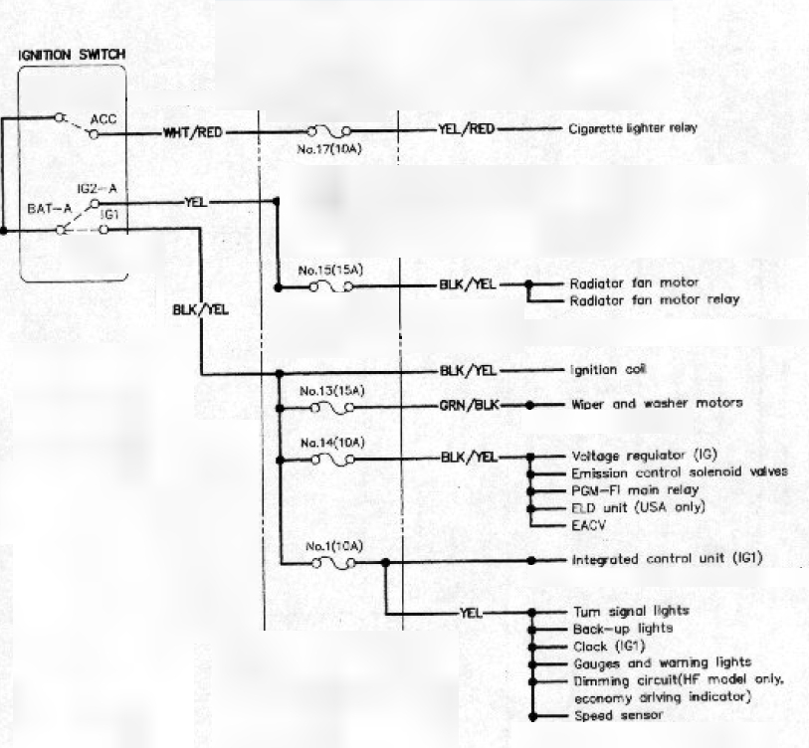

Figure iv Anticipated Ignition power Dis

**Description:**

1. **User input panel which holds ( replaces Honda O.E. Climate controls:**

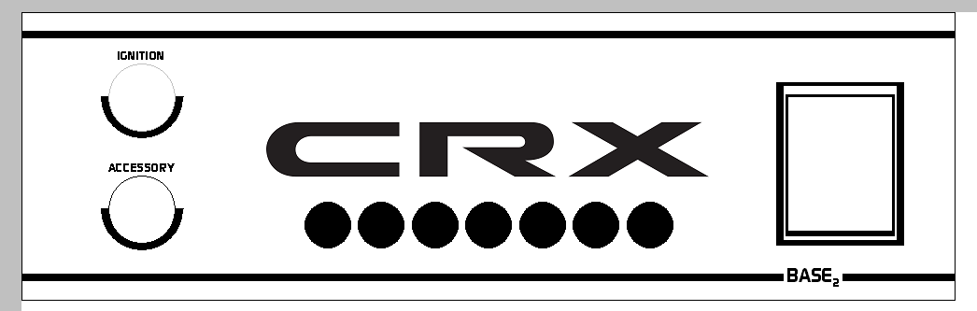

* 1. Ignition and accessory keys.
  2. 7 Status lights ( Brake boost, Nitrous primed, Exhaust cutout open, Blinders, etc. )
  3. ~~Push-button start (Security issues).~~
  4. RFID engine start

1. **User input panel ( replaces Honda O.E. upper middle air vents ):**

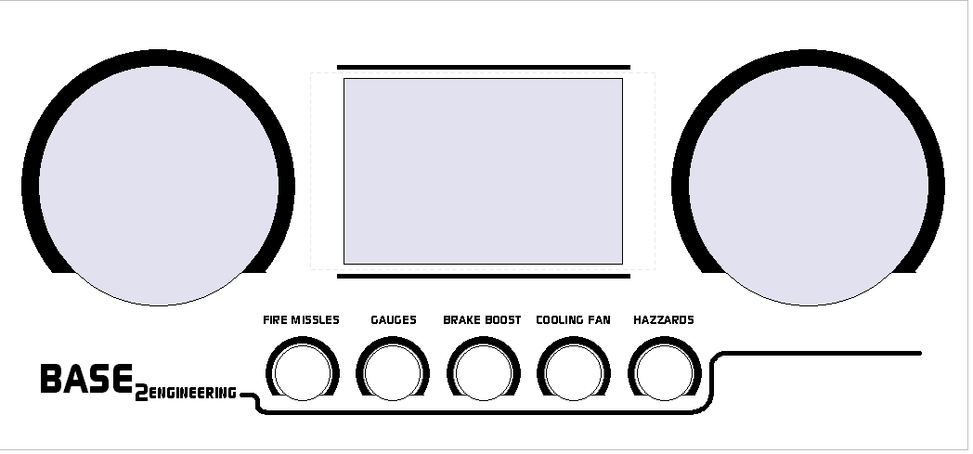

* 1. 5 push illuminated buttons (Depending on final design)
  2. Two 52mm gauges (Depending on final design)
  3. Nexton HMI touch screen (customizable) which controls and displays:
     1. Left and right windows / status
     2. Fuel quantity
     3. Engine temperature
     4. Engine status lights

Both sections 1 & 2 located in CRX/Panel.dsn ( CAD with dimensions )

1. **Integrated Alarm, startup control, sensor monitoring, Power distribution**